### GANDHI INSTITUTE OF TECHNOLOGY AND MANAGEMENT

**(Deemed to be University)**



**A Miniproject Report on**

**“Dehazing Results using Colour Ellipsoid Prior”**

Submitted in partial fulfillment of the requirement for the degree of

### Bachelor of Technology

**in**

**Computer Science and Engineering**

**Submitted by:**

|  |  |
| --- | --- |
| **STUDENT NAME:** | **REG NO:** |
| **R.SAI SANDESH** | **321810307039** |
| **B.SAI NATH REDDY** | **321810307012** |
| **B.LEELA YESHWANTH** | **321810307013** |
| **N.SREE CHARAN** | **321810307017** |

Under the guidance of

**Mr. HEMKUMAR**

Assistant professor

**Department of Computer Science & Engineering, School of Technology, GST**

**2021-22**



**GITAM**

**(DEEMED TO BE UNIVERSITY)**

**Bengaluru-**561203

## Department of Computer Science & Engineering

CERTIFICATE

This is to certify that the miniproject titled **“Dehazing Results using Colour Ellipsoid Prior”** is the bona fide work carried out by ‘**R.SAISANDESH,B.SAINATH REDDY,B.LEELA YESHWANTH,N.SREE CHARAN**’ With Roll no: **321810307039, 321810307012, 321810307013, 321810307017** student of B-Tech (CSE) of GITAM Deemed to be University, Bengaluru campus during the academic year 2021-2022, in partial fulfillment of the requirements for the award of the degree of Bachelor of Technology (Computer Science and Engineering). It is certified that all corrections/suggestions indicated for Internal Assessment have been incorporated in the Report deposited in the departmental library.

|  |  |
| --- | --- |
| Signature of the Guide | Signature of HOD |
| **Mr.Hemkumar** | **Prof. Vamsidhar Yendapalli** |
| Assistant professor | Head of the Department |

**Acknowledgement**

The Satisfaction and Euphoria that accompany the successful completion of any Seminar would be incomplete without mentioning the people who made it possible, whose constant guidance and encouragements crowned our efforts with success. We take this opportunity to express the deepest gratitude and appreciations to all those who held us directly or indirectly towards the successful completion of the Seminar.

I would like to thank **Dr. S DINESH**, Ph.D., Director, GITAM School of Technology for all the facilities provided.

I would like to thank **Prof. Vamsidhar Yendapalli** Professor-HOD, Department of **Computer Science and Engineering** for his support and encouragement that went a long way in successful completion of this Seminar.

I consider that as privilege to express our heartfelt gratitude and respect to **Mr.Hemkumar,** Assistant professor, department of Computer Science and Engineering for being our internal guide and also Seminar coordinator for his integral and incessant support offered to us throughout the course of this project and for constant source of inspiration throughout the Seminar.

I would like to thank our **parents** and our **friends** for their support and encouragement in the completion of project in time.

Last but not least I would like to thank all the teaching and non-teaching staff members of the **Computer Science and Engineering Department**, for the support in completion of the project in time.

**ABSTRACT**

The proposed method constructs color ellipsoids that are statistically fitted to haze pixel clusters in RGB space and then calculates the transmission values through color ellipsoid geometry. The transmission values generated by the proposed method maximize the contrast of dehazed pixels, while preventing over-saturated pixels. The values are also statistically robust because they are calculated from the averages of the haze pixel values.  Furthermore, rather than apply a highly complex refinement process to reduce halo or unnatural artifacts, we embed a fuzzy segmentation process into the construction of the color ellipsoid so that the proposed method simultaneously executes the transmission calculation and the refinement process. The results of an experimental performance evaluation verify that compared with prevailing dehazing methods the proposed method performs effectively across a wide range of haze and noise levels without causing any visible artifacts. Moreover, the relatively low complexity of the proposed method will facilitate its real-time applications.

TABLE OF CONTENT

1. INTRODUCTION 61
2. LITERATURE SURVEY 94
3. SYSTEM REQUIREMENTS 119

4. PROBLEM STATEMENT 162

5. DESIGNING 173

workflow 173

1. IMPLEMENTATION 195
2. TESTING 240
3. RESULTS: 266
4. CONCLUSION : 278

## 10. REFERENCES:………………………………………………………………………………....28 9

1. INTRODUCTION

Before going on to dehazing of image there are some things to be known. The first one is What is Haze In other words it is known as fog, It is a branch of open CV ) is an open source computer vision and machine learning software library. OpenCV was built to provide a common infrastructure for computer vision applications and to accelerate the use of machine perception in the commercial products . for reference hazed image looks like ..

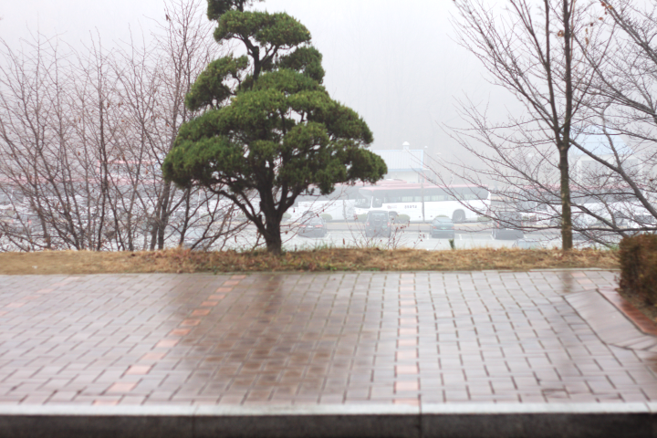

Fig: hazed image

We are going to dehaze the image by using single ellipsoid mechanism MANY competitive single-image dehazing methods are based on the dichromatic model , which describes a hazy image as a mixture of the transmitted portion of the haze-free image and the portion of the light source that reaches the camera. Describing the dichromatic model in the RGB color space, the vectors of the hazier pixels are the more densely clustered. The dehazing methods based on the dichromatic model select a vector to indicate the extent to which pixel colors are diluted or hazed by the atmospheric light; that vector is named the prior vector.

The prior vector could be selected from pixels or it could be calculated from the geometry of cluster distributions . Those methods then linearly stretch the hazy vector cluster from the atmospheric light to each hazy vector until any color components of the stretched prior vector become zeros or the stretched prior vector reaches to the origin . Thus, the selection of the prior vector determines the accuracy of transmission estimation and thereby the dehazing performance.

Dehazing the image using single ellipsoid sample image :

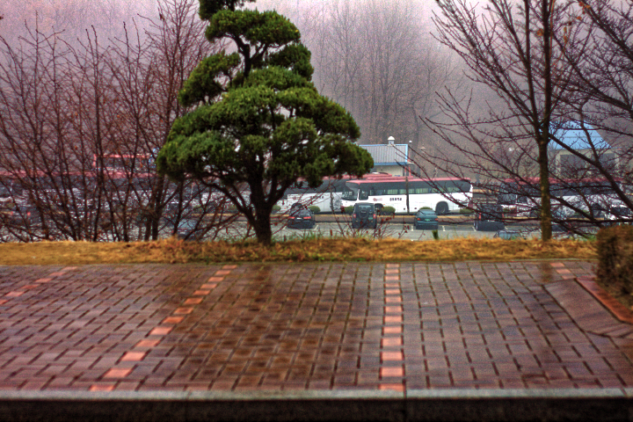

Fig: dehazed image

The phrase single image defogging is used to describe any method that removes atmospheric scattering (e.g., fog) from a single image. In general, the act of removing fog from an image increases the contrast. Thus, single image defogging is a special subset of contrast restoration techniques. In this article, we refer to fog as the homogeneous scattering medium made up of molecules large enough to equally scatter all wavelengths as described in .

Thus, the fog we are referring to is evenly distributed and colorless. The process of removing fog from an image (defogging) requires the knowledge on physical characteristics of the scene. One of these characteristics is the depth of the scene.

This depth is measured from the camera sensor to the objects in the scene. If scene depth is known, then the problem of removing fog becomes much easier. Ideally, given a single image, two images are obtained: a scene depth image and a contrast restored image.

The essential problem that must be solved in most single image defogging methods is scene depth estimation. This is equivalent to converting a two-dimensional image to a three-dimensional image with only one image as the input. The approach to estimating the scene depth for the purpose of defogging is not trivial and requires prior knowledge such as depth cues from fog or atmospheric scattering.

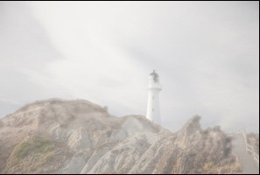

Fig: image contain haze

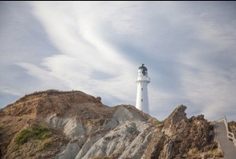

Fig: the same image looks in normal days

**2.** **LITERATURE SURVEY**

1. Single Image Dehazing Using Colour Ellipsoid Prior by Trung Minh Bui, and Wonha Kim published in 2019

**Color ellipsoid framework without fog:**

The general color ellipsoid model and its application to single image defogging was introduced by Gibson and Nguyen . This work will be reproduced here to facilitate the development of additional properties of the model in this article. The motivation for approximating a color cluster with an ellipsoid is attributed to the color line model in which is heavily dependent on the work from . The color line model exploits the complex structure of RGB histograms in natural images. This line is actually an approximation of an elongated cluster where Omer and Werman model the cluster with a skeleton and a 2D Gaussian neighborhood. Likewise, truncated cylinders are used.

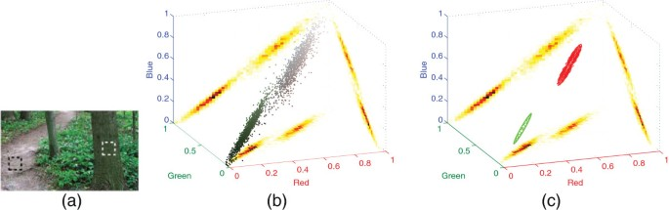

Fig: mechanism of color ellipsoid

**Color ellipsoid framework with fog:**

Color ellipsoids in clear natural scene. (a) Clear day scene with a sample window over the tree trunk (white rectangle) and a window over the road (black rectangle). (b) RGB histogram plot of points from the two windows with their densities projected on each color plane. (c) The same RGB histogram plot only with the ellipsoid approximations for each region of interest (ROI). The green ellipsoid is from the tree trunk, and the red ellipsoid is from the dirt road.

**2. Single image haze removal using dark channel prior**

By Sun J, and Tang X published in 2017

Haze removal1 (or dehazing) is highly desired in consumer/computational photography and computer vision applications. First, removing haze can significantly increase the visibility of the scene and correct the color shift caused by the airlight. In general, the haze-free image is more visually pleasing. Second, most computer vision algorithms, from low-level image analysis to high-level object recognition, usually assume that the input image (after radiometric calibration) is the scene radiance. The performance of many vision algorithms (e.g., feature detection, filtering, and photometric analysis) will inevitably suffer from the biased and low-contrast scene radiance. Last, haze removal can provide depth information and benefit many vision algorithms and advanced image .

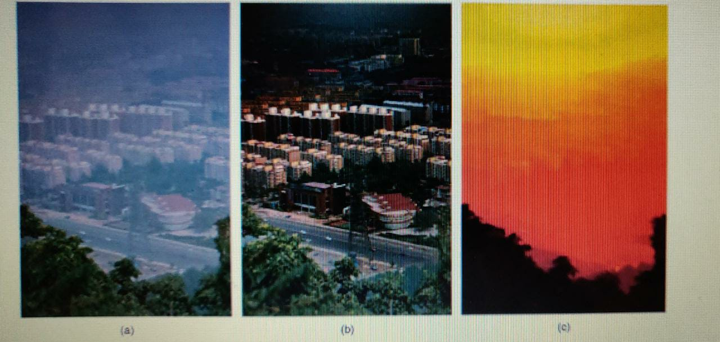

Fig:haze removal using single image e. (a) Input hazy image. (b) Image after haze removal by our approach. (c) Our recovered depth map.

**System requirement**

**Software Requirements:**

Keras and Tensorflow are required to build and execute image classification projects.

Keras is a Python deep learning framework, so you must have python installed on your system. In Ubuntu python.py is included by default, we recommend having the latest version of py. To check whether python3 is installed in your system or not:

Type python(.py) and

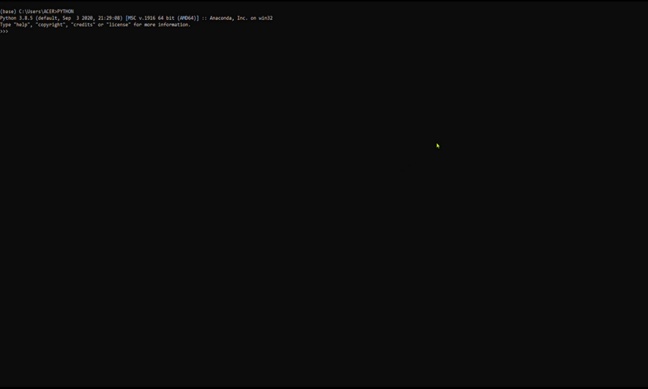

### Fig:to see python installed

### Anaconda python-3 Installation :

If python_3 had not installed in your system, then follow the below steps:

1.Open Browser of your choice and search of anaconda.com



Fig: Search for anaconda

2.Goto the first link you see the page as below



Fig: anaconda.iops

3.You will find the products drop down option, just drop down the list

4.click on individual edition



Fig: individual edition page

5.The page opens as shown and you have go to bottom of the page



Fig: anaconda installer

6.we are using windows 10 64 bit, so we have installed for it. Choose as per your OS

7.click on it



Fig. downloading anaconda

8.Give permission to make changes in your system

9.complete the post installation set up

**To install Jupyter notebook:**

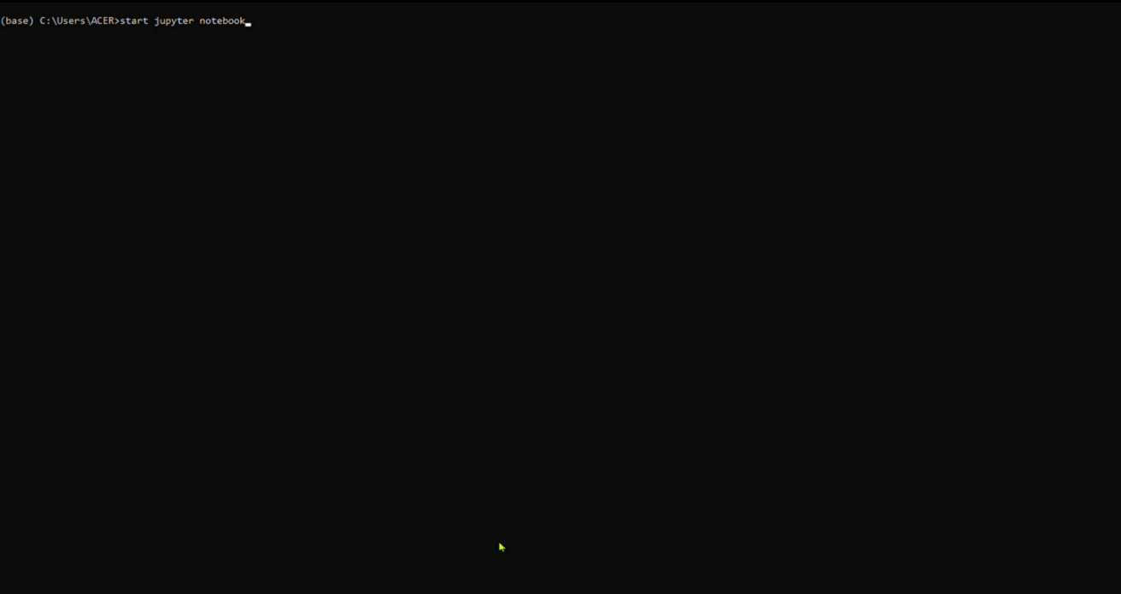Run Jupyter N

Fig :opening jupyter

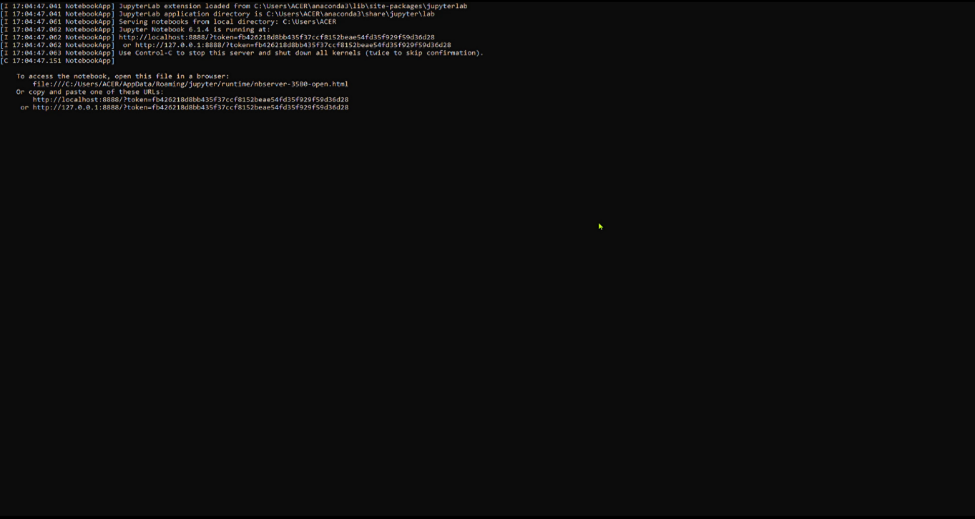

Fig: jnotebook



Fig: jupyter directed

You will be redirected

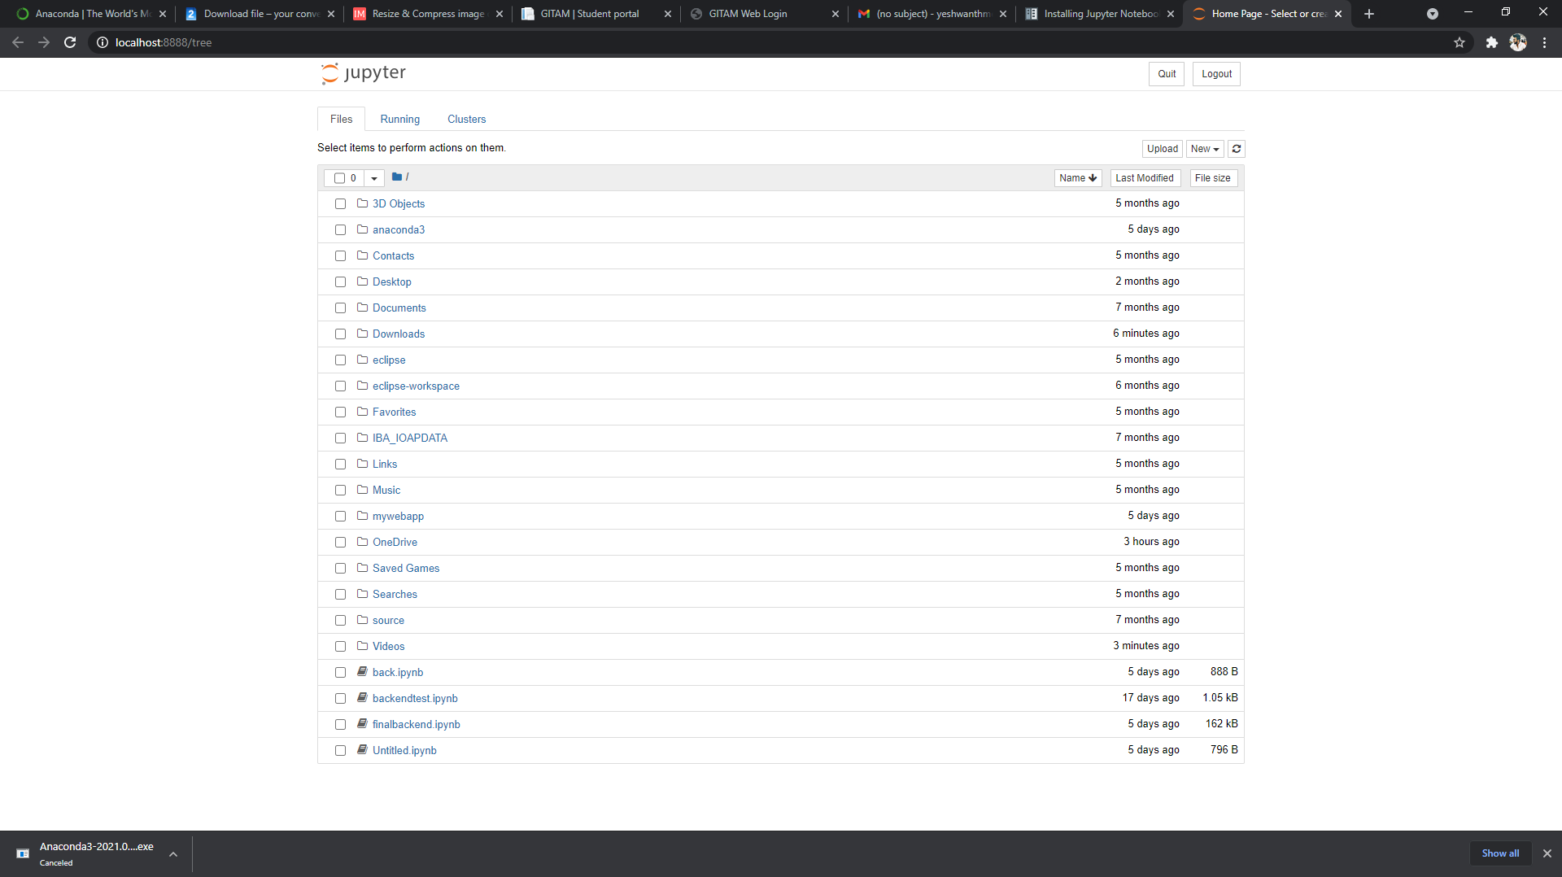

Fig: jupyter files

You can now able to find your files ,just open and test

**4. Problem statement**

In this domain, fog, haze and turbulence hinder the ability to observe objects of interest on the ocean surface. When fog is present, images presented to the sensor become low in contrast. Turbulence reduces the ability of an optical system to capture high resolution imagery and the structure of the images in time are perturbed severely. This work is an investigation of four problems not addressed specifically by the research community that exist in the development of an image or video surveillance system that is deployed in this domain.

The first problem is best formed as a question. Is it better to enhance contrast before image compression or after compression? It is common to require a surveillance system to compress the image data it is collecting, either through JPEG compression for images.

The next problem addressed is how fog is removed from a single image. There exist several methods that address this problem and are called single image defogging. This work presents a new Color Ellipsoid Framework that describes how single image defogging methods gain information from fog. Based on properties from the framework, a new single image defogging method is proposed.

In addition, a turbulence mitigation metric (TMM) is developed according to principles from the Color Ellipsoid Framework to provide a method of measuring temporal consistency

**5.Designing**

First Figure depicts the project's pipeline, which is divided into four categories. The material categories derived from the four datasets chosen for assessment are referred to as the input component. For the training and testing rounds of the procedure, each database was divided evenly

In NUMPY, NumPy is a Python library used for working with arrays.It also has functions for working in domain of linear algebra, fourier transform, and matrices.

Opencv provides a realtime optimized computer vision library, OpenCV is used for all sorts of image and video analysis, like facial recognition and detection, license plate reading, photo editing, advanced robotic vision, optical character recognition, and a whole lot more.

**Work flow:**

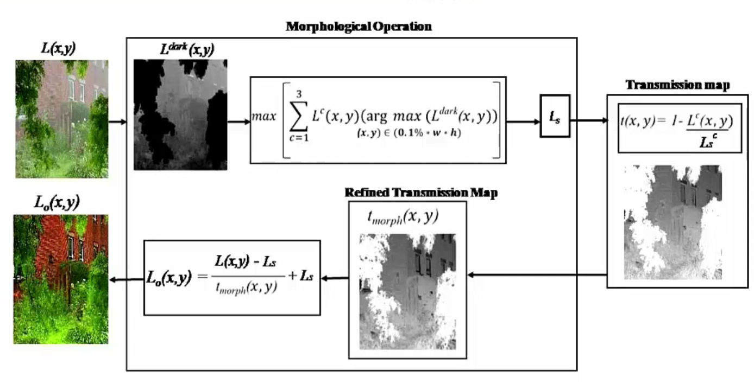

**Fig: work flow**

The phrase single image defogging is used to describe any method that removes atmospheric scattering (e.g., fog) from a single image. In general, the act of removing fog from an image increases the contrast. Thus, single image defogging is a special subset of contrast restoration techniques.

The process of removing fog from an image (defogging) requires the knowledge on physical characteristics of the scene. One of these characteristics is the depth of the scene. This depth is measured from the camera sensor to the objects in the scene. If scene depth is known, then the problem of removing fog becomes much easier. Ideally, given a single image, two images are obtained: a scene depth image and a contrast restored image.

**6.Implementation**

Opening jupyter notebook

Through prompt

Providing the output of defoged image

Performing refined transmission map

Converting the dark channel image to transmission map

Converting the fog image to dark channel image

importing the fog image

First of all importing the required libraries which are required for this project ,

We have imported the numpy as well as opencv and time libraries.

In every note book all the libraries are not included we need to install by using pip command in prompt. 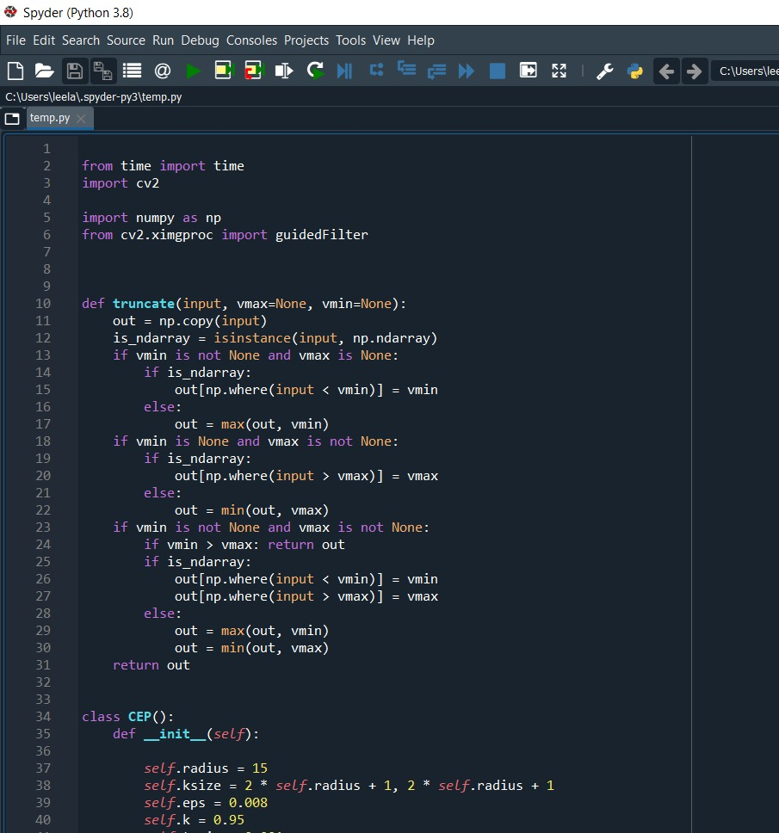 fig: implementation part 1

We are going to calculate the atmospheric light and preserve the non –hazed areas in the image .

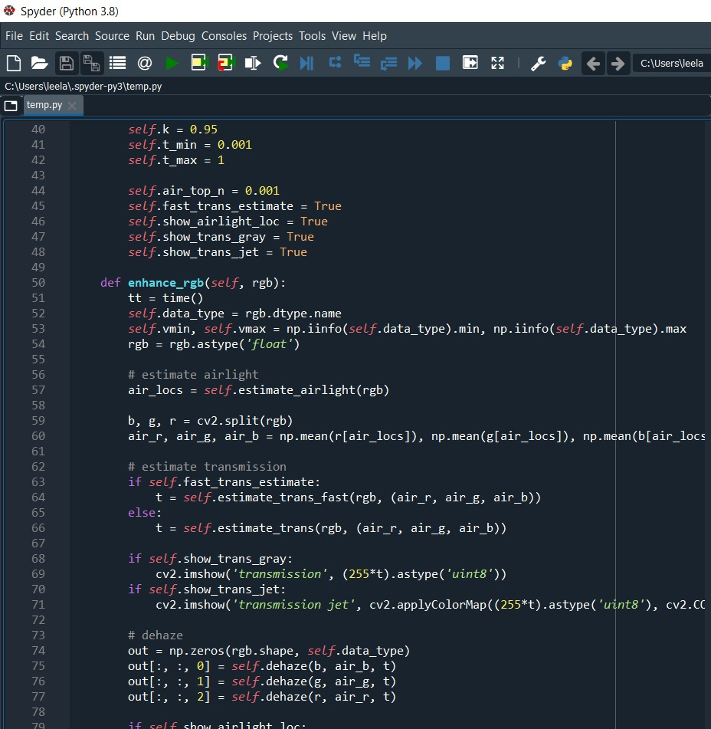

Fig: implementation part 2

Then we use gray scale morphological method:

We have image and applied dark channel is minimum of pixel intensity and some light are added in the image and we us gray scale method ,we have choosen 0.1% of dark channel prior method and estimating the core transmission map.

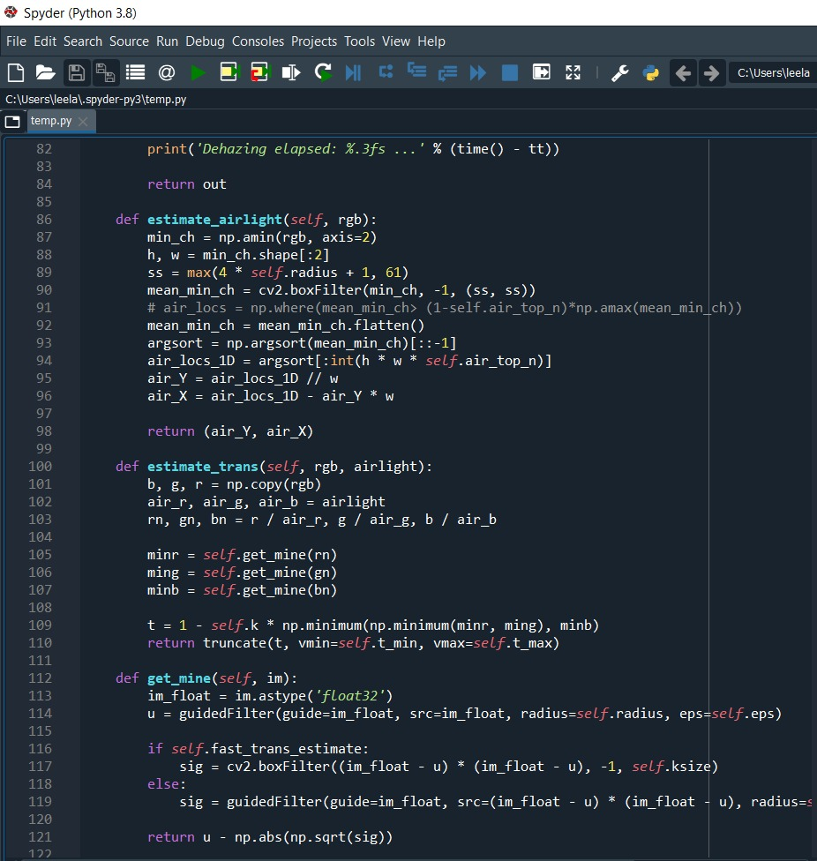

Fig : Implementation part 3

If even after estimating the atmospheric light but some artifacts are still present in that transmission map so we need to refine the transmission map .

So we again use the gray scale morphological operation to preserve our red, green, blue (r,g,b) we can recover our scene radiance.

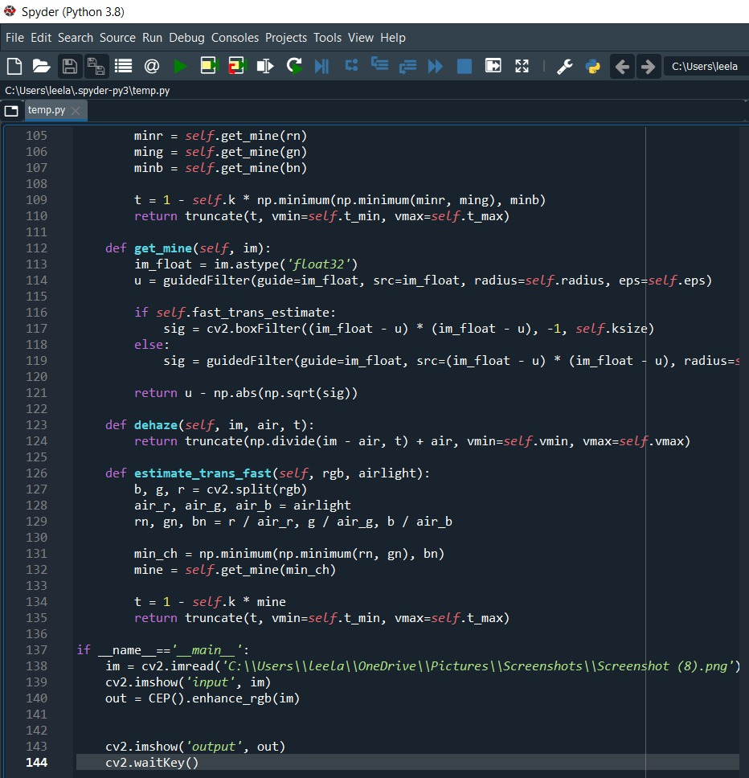

Fig: implementation part4

**7.Testing**

Step 1:

input image which contain haze

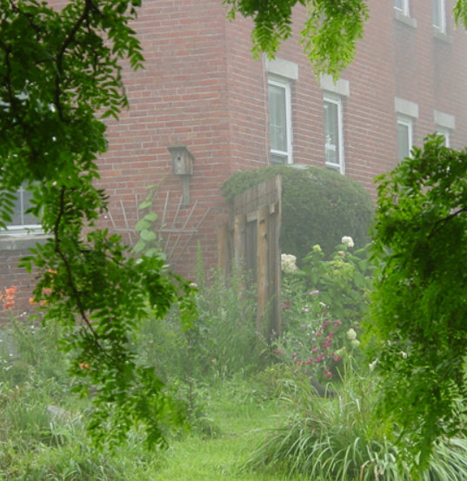

Step 2:

Converting in to dark channel image

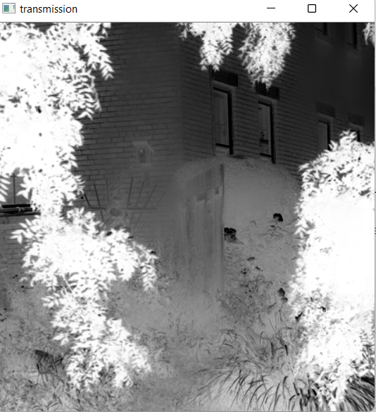

Step 3:

Dark channel image to thermal or transmission map image

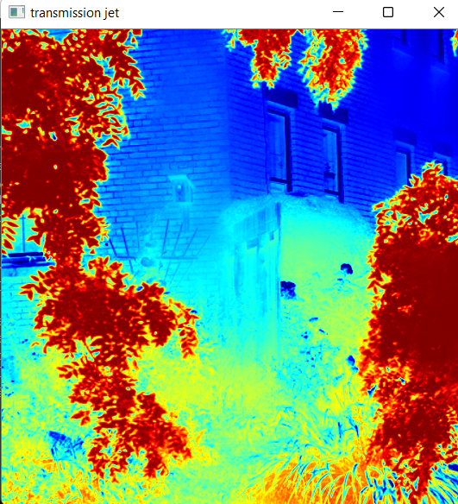

Step 4:

Perform refined transmission and providing dehazed image

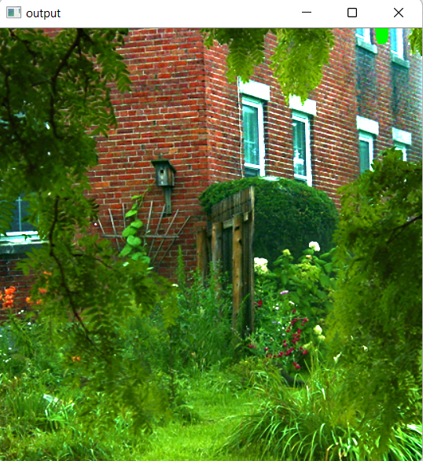

**8 .Results**

**9 . Conclusion**

The development of the color ellipsoid framework is contribution to the field of work in single image defogging because it brings a richer understanding to the problem of estimating the transmission. This article provides the tools necessary to clearly understand how transmission is estimated from a single foggy day image.

We have introduced a new method that is visually more aggressive in removing fog which affords an image that is richer in color.

Future work will include the color ellipsoid framework in the development of a contrast enhancement metric. Additionally, the ambiguity problem when estimating the transmission will be addressed using the orientation of the color ellipsoid to develop a more accurate transmission mapping with respect to the depth of the scene.

We present a new way to model single image defogging methods using a color ellipsoid framework .

**10.Reference**

1. Single Image Dehazing Using Colour Ellipsoid Prior by Trung Minh Bui, and Wonha Kim published in 2019
2. Single image haze removal using dark channel prior

By Sun J, and Tang X published in 2017

3. SG Narasimhan, SK Nayar, Contrast restoration of weather degraded

images. IEEE Trans. Pattern. Anal. Mach. Intell. 25(6), 713–724 (2011)

4. D Summers, Contrapposto: style and meaning in renaissance art. Art Bull.

59(3), 336–361 (2009)

5. H Koschmieder, Luftlicht und Sichtweite. Naturwissenschaften 26(32),

521–528 (2001)